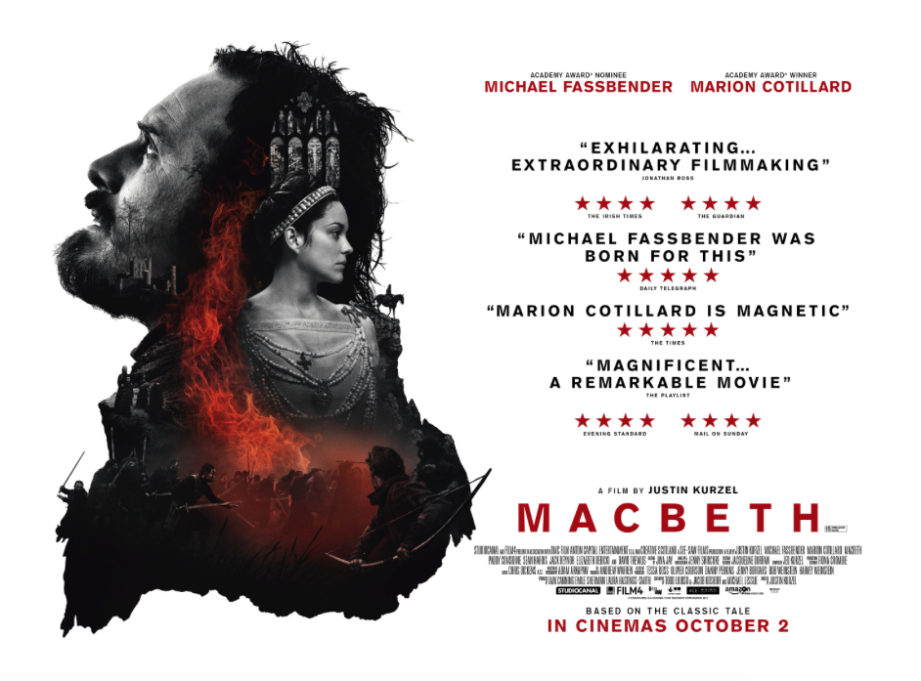
Purpose - This posters purpose is to advertise the film, but also shows who the films is directed by, who stars in it. It also states how it is based on the classic Shakespeare play as well as its release date. The persuasive techniques the posters focusses on is the reviews from critics, telling the audience that it is a visually thought-provoking film with strong performances from the lead actors, some viewers will be interested in that aspect, most particularly the older generation.

Colour/Symbolism – The main colours used in this poster are; red, black and white. The black may symbolise how dark and tragic the film will be as the play is a tragedy. The dark red usually has connotations of blood (which plays a significant part in the play) that will be shed throughout the film. The darker red helps the words stand out and capture the audience eyes. The use of white helps contribute in making the darker colours more eye-catching, which is the posters aim, to grab the audience’s attention.

Layout – The posters layout is clear, its image is on the left and the text is on the right hand side, this is different to most posters which usually have the text overlapping the image but this style allows both pieces to stand out, with its visually striking image not being obstructed by the text, which is laid out in a very formal style and not all over the place.

Text Colour – The main colours of the text are black and white which helps to stand out in the plain white background. The red perhaps symbolising the blood and fits into the style of the film as red is associated with danger.
Reaction – Upon first glimpse of the poster I would say that it is a very effective poster, its strong bold colours catching my attention and its strong imagery most particularly the vibrant flame and the layout of each image, creating a very memorable montage. As a viewer after seeing this poster I would expect a visually striking film with deep, dark performances.

Realism – The way the poster is designed is to create a sense of realism in the specific time period in which the film is set, this is established in the clothing they are wearing and the positioning of the characters, which help contribute to the gritty and twisted style of film. It will not be fun and over the top, but a more morbid and melancholy film.

Key Image – The key image in this poster is the overlapping shots that are most taken from the film itself. The use of a montage of graphical images offers insight for the audience. The positioning of the montage could also be seen as a map of Scotland where the events take place in the film. The two main characters; Macbeth and Lady Macbeth are the main focus of the image, with Macbeth taking a higher and larger position. Macbeth in the poster is looking upwards perhaps in a pose similar to prayer, this will trigger a thought in the audience, that he has committed a crime and is seeking forgiveness, this is further emphasised with the inclusion of a church stain glass window. There are also smaller images featured in the poster, such as: the castle, the three witches and a man on horseback which all play a role in the film. A main standout in the image is the trailing flame which blatantly stands out from the black and white images not only eye-catching but giving a glimpse into the battle which will commence in the film.

Target Audience – Its intended audience would be to those who are perhaps a fan of the Scottish play or of Shakespeare’s works, or perhaps a viewer who is interested in watching a dark, tragic drama film as the poster suggests itself that it will be a morbid piece of cinema with strong, dramatic performances from Fassbender and Cotillard. Its USP being that it is a film adaptation of Shakespeare’s Macbeth.

Tagline – ‘Based on the classic tale’ immediately tells the audience that it is a film adaptation of a play, however, due to its popularity the fact that it is Shakespearian is not stated as Macbeth is popular, it is simply telling them it is another faithful but serious adaptation of the play. ‘Based’ tells the audience that the film may stray from the original slightly, allowing the filmmaker to imbed his own ideas into the film.

